**Project Report: Offline Voice Assistant using Vosk and Python**

**1. Title**

**Offline Voice Assistant Using Vosk, PyAudio, and Tkinter GUI in Python**

**2. Abstract**

This project presents the design and implementation of an **offline voice assistant** capable of recognizing speech and responding to predefined queries using natural voice synthesis. The assistant is built using the **Vosk speech recognition library**, **PyAudio** for capturing audio input, and **pyttsx3** for offline text-to-speech. A simple **Tkinter GUI** is also implemented to display status updates, recognized queries, and corresponding responses in real-time. The system functions without internet connectivity, making it suitable for secure or limited-access environments.

**3. Objectives**

* Implement a fully offline voice-controlled assistant.
* Recognize and interpret voice commands using Vosk.
* Provide audio responses using pyttsx3.
* Display status and interaction logs using a GUI.
* Maintain a log of user queries and system responses.

**4. Tools and Technologies Used**

| **Tool/Library** | **Purpose** |
| --- | --- |
| Python 3.x | Programming Language |
| Tkinter | GUI development |
| Vosk | Offline speech recognition engine |
| PyAudio | Audio stream handling from microphone |
| pyttsx3 | Offline text-to-speech engine |
| difflib | Approximate string matching for fuzzy queries |
| threading | To prevent UI blocking during recognition |

**5. System Architecture**

**Modules:**

1. **VoiceAssistant Class**
   * Handles microphone input, speech recognition, query matching, response generation, and logging.
2. **AssistantGUI Class**
   * Provides a simple, clean interface for displaying system status, user input, and assistant response.
3. **Keyword Detection & Fuzzy Matching**
   * Recognizes key phrases (e.g., "cobot", "AI") and handles unknown queries using difflib.
4. **Offline Models**
   * Utilizes vosk-model-small-en-in-0.4, an Indian English acoustic model, for accurate recognition without internet.

**6. Working Principle**

1. The assistant waits in standby mode until it hears the keyword **"assistant"**.
2. Upon activation, it listens for a command.
3. The input speech is converted to text using the **Vosk recognizer**.
4. The query is matched with predefined commands.
5. The corresponding response is:
   * Shown in the GUI.
   * Spoken out using pyttsx3.
   * Logged in a text file with timestamps.
6. The system returns to standby mode after a response.

**7. Features**

* Works entirely offline.
* Clean and responsive GUI.
* Keyword and fuzzy-based query matching.
* Logging of interactions to conversation_log.txt.
* Voice feedback via text-to-speech.
* Error handling for failed recognitions or model loading.

**HIGH-LEVEL DIFFERENCE:**

| **Feature** | **Earlier Version** | **Improved Version (This One)** |
| --- | --- | --- |
| **Response Type** | MP3 Audio Files (pre-recorded) | Fully dynamic TTS (speaks using pyttsx3) |
| **GUI Interface** | None | Yes (with status, input, and response shown) |
| **Logging** | No logs saved | Saves logs with timestamps in a .txt file |
| **Speech Accuracy** | Only keyword matching | Keyword + close match with difflib (fuzzy logic) |
| **Listening Feedback** | None | GUI shows real-time status and timestamps |
| **Activation Word** | Yes, hardcoded word "assistant" | Still present with standby and active mode GUI |
| **Internet Check** | Has fallback between online/offline | This version is fully offline for now |
| **Streaming Handling** | Opened once at start | Smart stream start/stop to save resources |
| **Custom Error Messages** | Minimal | Detailed error logging if model not found etc. |

**8. Sample Predefined Commands**

| **User Query Keywords** | **Assistant Response** |
| --- | --- |
| "what is a cobot" | A cobot is a collaborative robot designed to work safely with humans. |
| "what is ai" | AI stands for Artificial Intelligence... |
| "tell me a joke" | Why did the robot go on vacation? It needed to recharge! |
| "bye", "exit", "quit" | Goodbye! Have a great day. |

**9. Advantages**

* No dependency on internet services (unlike Google Assistant or Alexa).
* Ensures user privacy as audio stays local.
* Lightweight and customizable.
* Educational value for understanding ASR and GUI integration.

**10. Limitations & Future Scope**

| **Limitation** | **Possible Improvement** |
| --- | --- |
| Only predefined responses | Add GPT-based or dynamic response generation |
| No continuous conversation context | Add NLP state management |
| Fixed commands in code | Allow external JSON configuration |
| No command to stop assistant from GUI | Add GUI-based "Stop/Exit" button |

**11. Screenshots**

* GUI Interface showing "Listening" and "Response"
* Console logs or conversation_log.txt sample

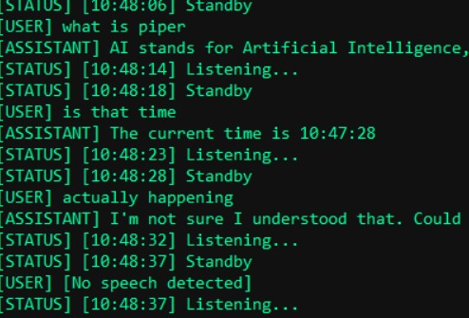

**12. Conclusion**

This project successfully demonstrates an offline voice assistant built with open-source Python libraries. It emphasizes privacy, offline accessibility, and customization. The assistant can be enhanced further for industrial, educational, or home automation use cases.